Marine Conservation and the Roles Aquariums Play

Simon Dean
COMP 3125 – Data Science Fundamentals

Keywords— AZA (Association for Zoos and Aquariums), OSS (OurSharedSeas), Seaborn

Introduction (Heading 1)
Marine Conservation is a very topical discussion now, given the current concerns over global warming and climate change. Marine life is something that should be preserved and protected for both the benefits of them and us. At the forefront of this conservation are aquariums, which play a vital role in preserving endangered species and engaging the public more on marine conservation. Most aquariums are non-profit, meaning any money they make are sent towards conservation funds or maintenance. Some however, like SeaWorld, are for profit, and can hurt the conservation efforts of others. This report plans to see just how big of role aquariums play in marine conservation.

Datasets

Source of dataset (Heading 2)
https://www.aza.org/zoo-and-aquarium-statistics

The Association for Zoos and Aquariums, or AZA as it’s better known, is one of the most credible sources for information pertaining to marine conservation and a comparison of for-profit and non-profit institutions. Many of the sets have very recent updates, the oldest being April 2023.

https://oursharedseas.com/funding/
OSS is another credible source for information pertaining to marine conservation. Several of its sets are a tiny bit dated however, with the most recent being 2022.

Character of the datasets

The AZA dataset was not very clean outside of providing a reliable source for aquariums. Much of the data cleaning required individually going through each aquarium for information. The OSS dataset however, was VERY clean, needing little altering whatsoever.

Methodology
The model I will be planning on using is a linear regression model, which attempts to model the relationship between a target variable and predictor variables via a linear equation:
y = β0 + β1X1 + β2X2 + …. βnXn + ϵ.
Linear regression assumes multiple things. It assumes that the relationship between the predictors and the target variable is a linear one, assumes that residuals are independent of one another, constant across all levels of the predictors, and roughly follow a normal distribution, and finally that the predictor variables are not extremely correlated with one another.
Linear regression has its advantages as well as its disadvantages. For one, it’s easily accessible, as the coefficients show how each variable affects a prediction. It’s fast to compute, and it’s easy to visualize. However, it’s also extremely sensitive to outliers, only assumes linear relationships, and can predict decimals or negatives. Despite this, linear regression was chosen for its ease of accessibility, and the dataset being decently small compared to others means the model will have an even easier time computing it.

The Python modules that will likely be used will be Pandas, a data frame library, and Seaborn as the main visualizer for linear regression. This is because Seaborn has built in regression plotting, is great for comparing multiple variables, and can quickly check linear assumptions.

Results
Results A.
The first question was done with a linear regression and Seaborn, as I believed that trying to predict the endangered species based on size, location, and funding would benefit from it. As such, multiple graphs were needed to see.
Graph A.
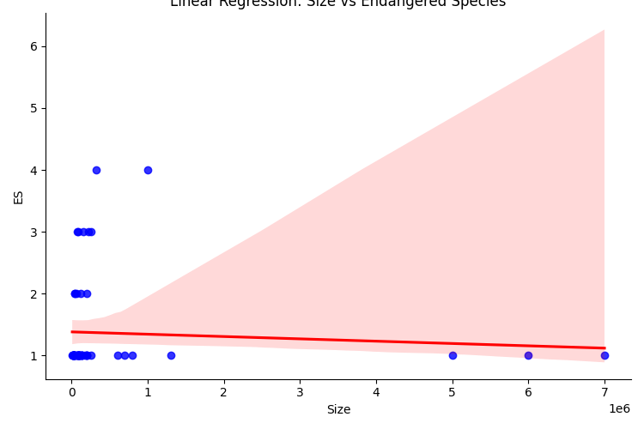
This graph is based on size. As one can see, it’s fairly negative, which could be a sign of size not being fairly reliable for a predictor.
Graph B.
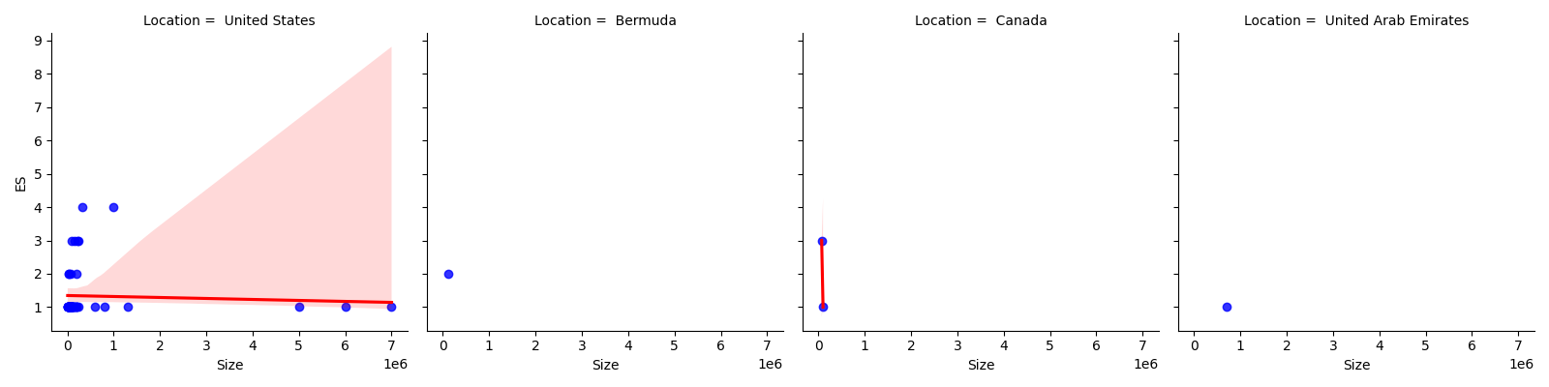
This one is based on location. While the first location (US) is basically just the size again, the others are very much outliers, indicating that location is also not a very good predictor for how many endangered species are preserved.
Graph C.
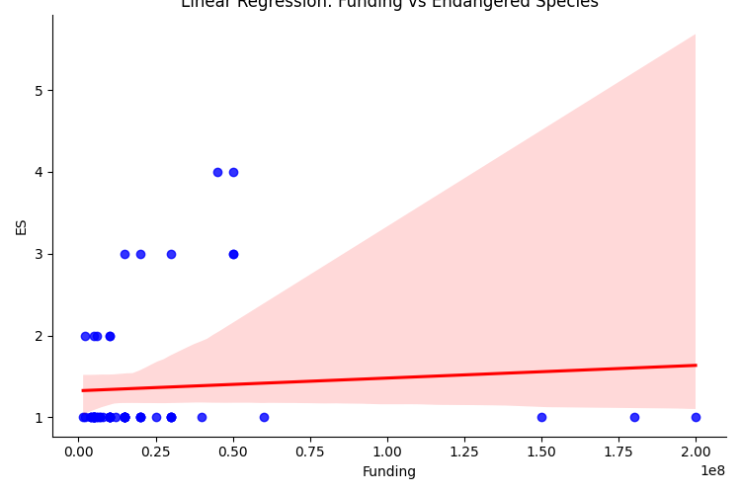
This graph is based on funding. In contrast to the other two, there actually a slight positive line, indicating that there could be some intersection with how much funding an aquarium gets and how many endangered species are preserved.
Overall, the answer to the original question is: There might be a way to predict endangered species based on size, location and funding, but it’s not likely to produce meaningful or positive results.
Results B.
The second question was done via pie chart, as it’s comparing 2 groups: A non-profit group, and a for-profit group.
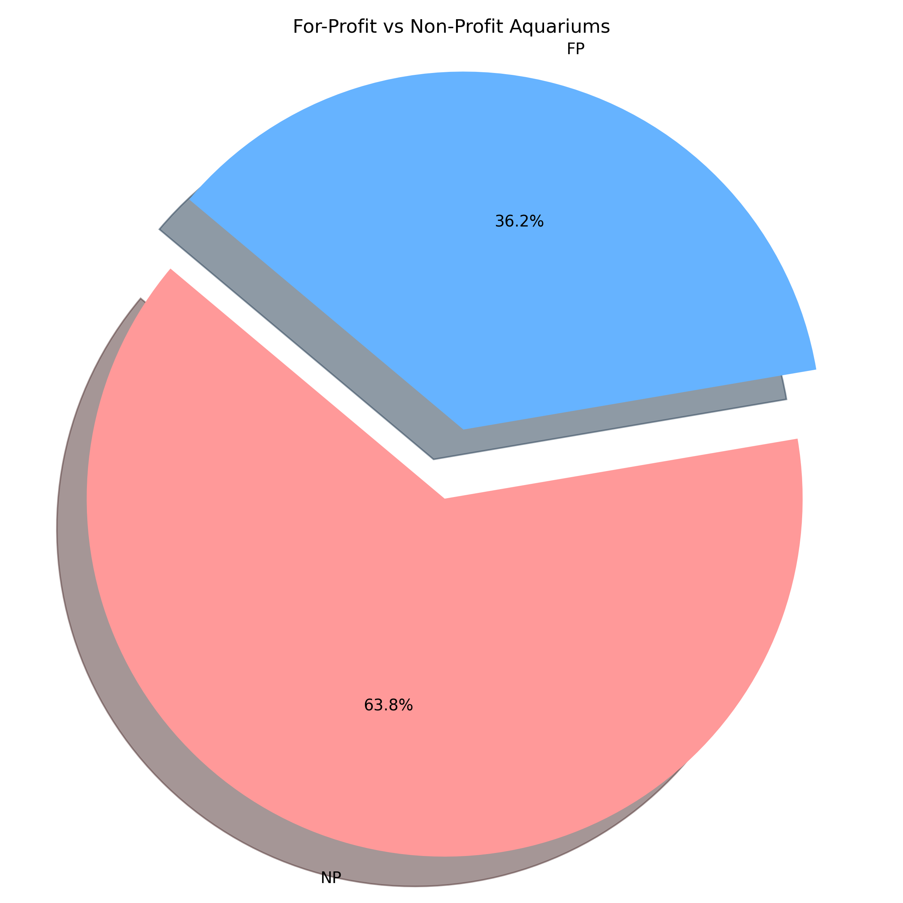
As seen here, about 1/3 of the aquariums listed are for-profit, with the rest being non-profit. This is only mildly surprising as a lot of research prior to this indicated there would be less for-profit aquariums than what was listed, but this can be attributed to the fact that the selection of aquariums was a fairly small sample compared to most lists. It should noted that many of the for-profit aquariums are owned by entertainment properties, like SeaWorld and SEALIFE.
Results C.
The third and final question was done with a horizontal bar chart, as I believe that to be the best way to compare a lot of data comparing with one another at once, and to show an easier way of who contributes more compared to one another.
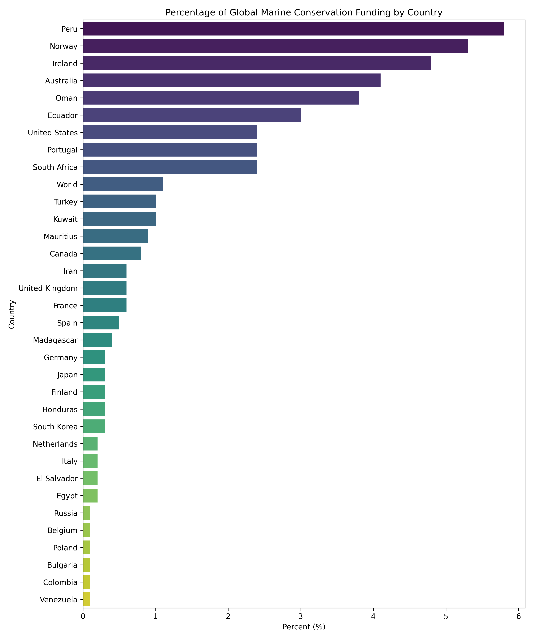
As one can see, the countries that produce the most are fairly stable, wealthy countries that border water. The most surprising result was that the US, despite composing of most of the aquariums listed in previous questions, was not among the countries contributing the most. Instead, it was Peru, which didn’t have any aquariums from the list. In fact, most of the countries listed did not have aquariums from the list. Of course, that isn’t to say they don’t aquariums whatsoever, but it shows that aquariums are not as major a factor for marine conservation as many, myself included, think they are.

Discussion
The most unsatisfying result would have to be the linear regression not really producing meaningful results. In the future, perhaps using another model or testing more with linear regression with other libraries could produce an improved, better result than what was shown. Seeing more international aquariums and their funding could also prove helpful for the future. Many of the aquariums researched in this report were US-based, so seeing how other aquariums from different countries are funded, are for or non-profit, and how they preserve endangered could prove beneficial.

Conclusion
The important results I found were how aquariums, while helpful, are not the major factor in marine conservation that I believed they were, despite how well funded they get. I also found that thankfully, many are non-profit, meaning that for those aquariums, marine conservation is most likely a bigger priority than entertainment.

References

[1] Association of Zoos and Aquariums, “Zoo and Aquarium Statistics | AZA,” Aza.org, 2000. https://www.aza.org/zoo-and-aquarium-statistics

[2] “Funding Trends 2023: Tracking the State of Global Ocean Funding,” Our Shared Seas. https://oursharedseas.com/funding/

[3] “Find a Zoo or Aquarium Near Me | AZA,” Aza.org, 2019. https://www.aza.org/find-a-zoo-or-aquarium
‌

